`

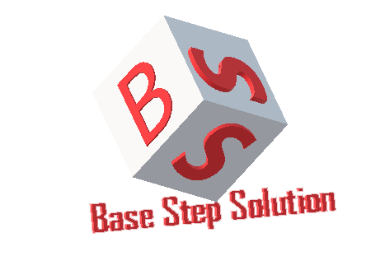

Meeting Minutes

Van Lang Admissions

# Revision Table

|  |  |  |  |
| --- | --- | --- | --- |
| Author | Date | Reason for changes | Version |
| Khoi Nguyen | 09/01/2017 | Initial Document | 1.0 |

Table of Contents

Revision Table 1

I. Purpose 3

II. Participant in meeting 3

III. Content of meeting 3

IV. To do task 4

|  |  |  |  |  |  |
| --- | --- | --- | --- | --- | --- |
| **Writer:** | Khởi Nguyễn | **Location:** | Floor 9, Etown 2 | | |
| **Date:** | 09/01/2017 | **Start:** | 12h | **Finish:** | 15h |

# Purpose

Discuss about progress of Capstone Project

Review process, schedule & usecases

# participant in meeting

Mentor Vũ Thế Nam

Team Capston:

* Nguyễn Thái Hiền
* Nguyễn Hoàng Anh Tài
* Đoàn Anh Minh
* Trần Xuân Hải
* Nguyễn Xuân Thái Hiền
* Nguyễn Anh Khởi

# Content of meeting

* After each meeting, write the meeting minute, and make an excel sheet listing what has been completed.
* Why use incremental process ? – Each member list 3 comment to explain about why the incremental process should bi used?
  + The incremental process is the same waterfall process as Requirements unchange.
  + Test in each phase, if there is a problem, you can add a new incre or pass to the next increment, then update the plan and get the approval by the customer.
* Working in a loop ( Update – Review – Approve )
* Review Change Management Process
  + Change Control Board : Related to Phase Leader , Technical Leader , Project Leader , Customer … not related to Mentor
  + -> Add phase -> Update phase -> Request Change ..
* Review Risk Management Process
  + Need to add process when risk occurs.
  + Uncleare activities : Concern , Implement , Measure in process.
  + Mentor has a solution that should separate many processes ( Process to determine risk, process handling risk … )
  + List Risk change to Identify/Review Risk
  + Measure & Control -> process handling risk
  + Risk action : depending on the type of risk
* Review Usecase Description : add column status , who , what , how.
* Meeting mentor : Monday morning at school and Thursday evening at Etown 2

# To do task

* Update Requirement
* Priority do physical view
* Reduced priority of fix process

---- *** ----